**DAILY ONLINE ACTIVITIES SUMMARY**

|  |  |  |  |  |  |  |  |
| --- | --- | --- | --- | --- | --- | --- | --- |
| **Date:** | **21/06/2020** | | | | **Name:** | **Churashma** | |
| **Sem & Sec** | **4th SEM 'A' Section** | | | | **USN:** | **4AL18CS019** | |
| **Online Test Summary** | | | | | | | |
| **Subject** | | **No test** | | | | | |
| **Max. Marks** | | **-** | | **Score** | | **-** | |
| **Certification Course Summary** | | | | | | | |
| **Course** | **Introduction to R** | | | | | | |
| **Certificate Provider** | | | **greatlearning academy** | **Duration** | | | **3.5 hours** |
| **Coding Challenges** | | | | | | | |
| **Problem statement 1: JAVA program to convert a string from uppercase to lowercase without using string method.** | | | | | | | |
| **Status: completed** | | | | | | | |
| **Uploaded the report in Github** | | | | **yes** | | | |
| **If yes Repository name** | | | | **https://github.com/Churashma/Lockdown-coding** | | | |
| **Uploaded the report in slack** | | | | **yes** | | | |

ONLINE TEST DETAILS: No test.

CERTIFICATION COURSE DETAILS:Today I studied about importing data and data manipulations. Currently, one of the most common ways of storing and sharing data for analysis is through electronic spreadsheets. A spreadsheet stores data in rows and columns. It is basically a file version of a data frame. When saving such a table to a computer file, one needs a way to define when a new row or column ends and the other begins. This in turn defines the cells in which single values are stored.One of the most important aspects of computing with Data Manipulation in R is that it enables its subsequent analysis and visualization. Let us see a few basic data structures in R.

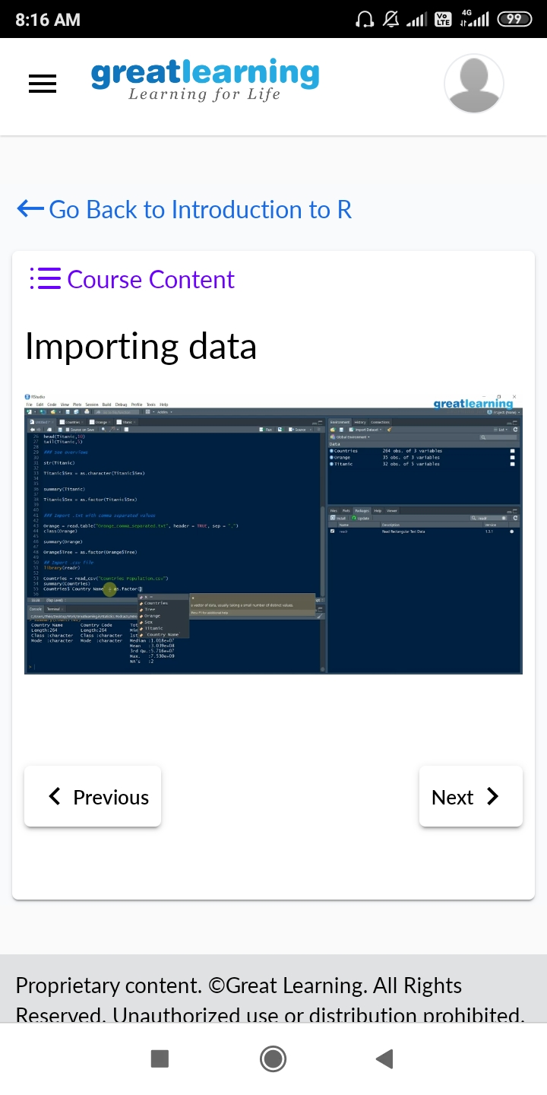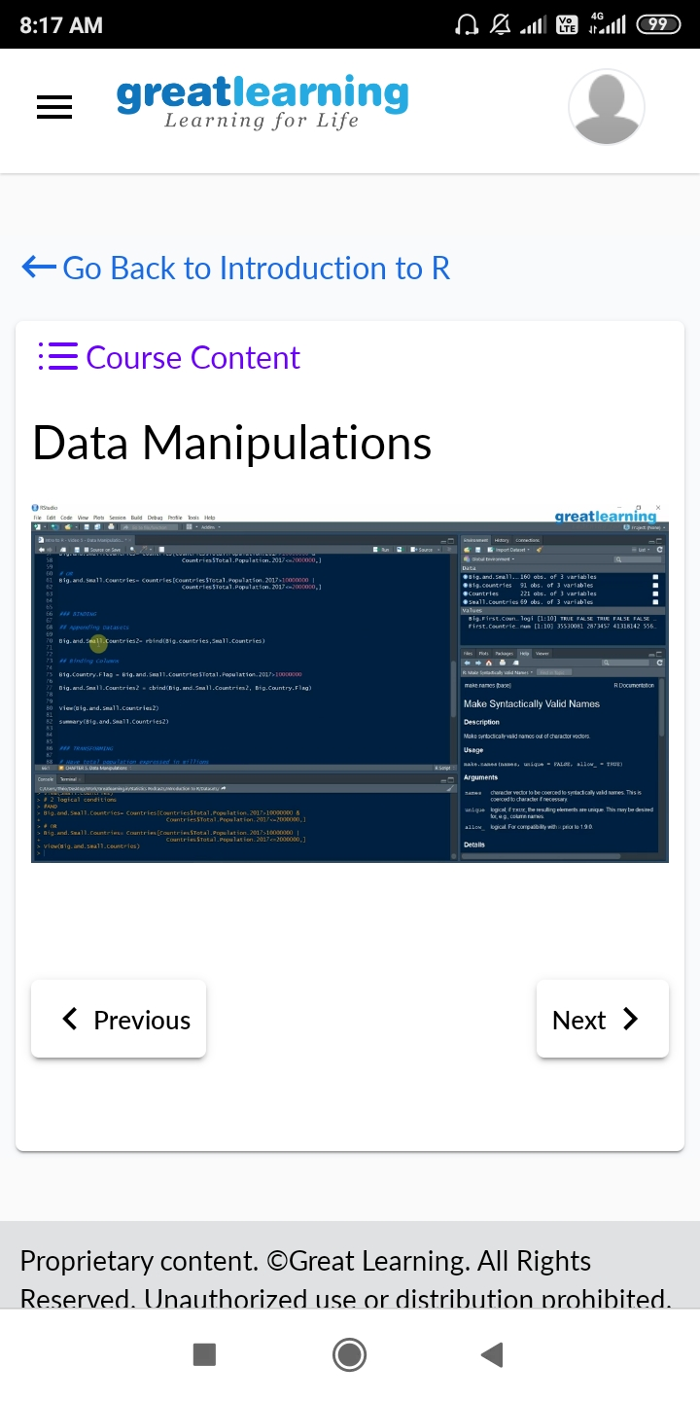

**CODING CHALLENGES DETAILS**:

**Problem statement 1:**  JAVA program to convert a string from uppercase to lowercase without using string method.

